**Is there a correlation between the population of English-Only speakers to the amount of incidents that occur in that population?**

There is a correlation between populations with a low english-only speaking population to number of Hate Crimes (except for a bias motivation of disability). This is evidenced by pearson scores between .4 and .6 with significant p values for all types of hate crimes, except for hate crime concerning disabilities.

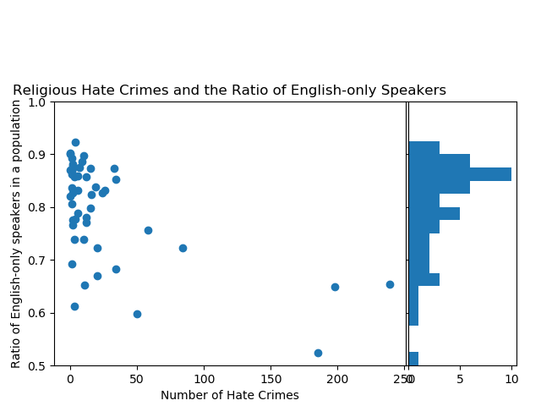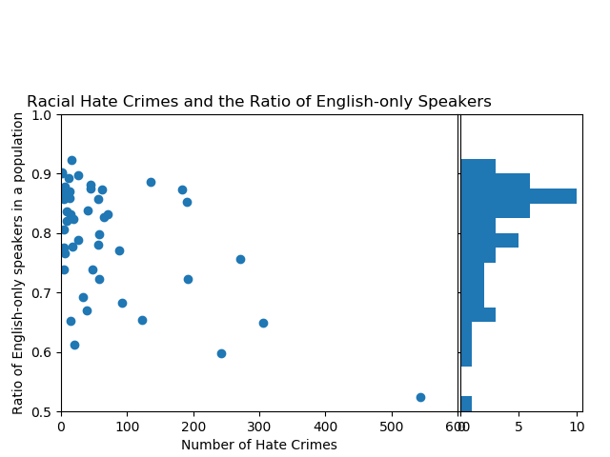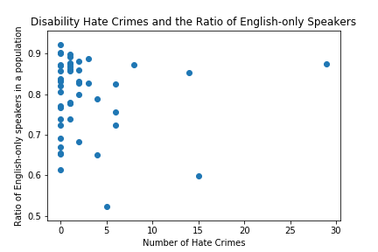Race (-0.5474155325921943, 4.6904447245066614e-05)  
Religion (-0.5766945328172296, 1.4446413510251614e-05)  
Sexual Orientation (-0.5466954394263093, 4.821656664722198e-05)  
Disability (-0.03339095883123549, 0.8198280175299527)  
Gender/Gender Identity (-0.44290016236111207, 0.0014382354940464539)

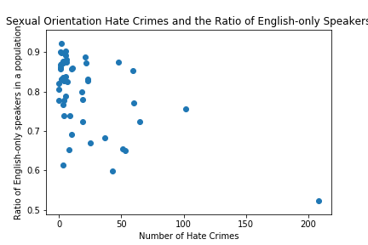

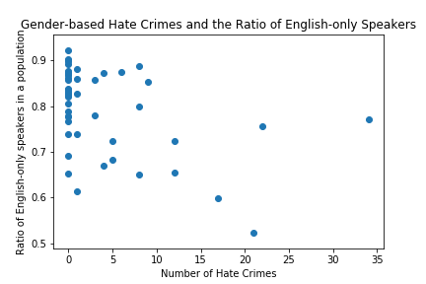

**What is the most common type of Hate Crime across the United States?**

- The most common Hate Crime offense types are intimidation to persons and destruction/damage/vandalism to property. The most common Bias Motivation is for Race/Ethnicity.

**Where do Hate Crimes most commonly occur?**

-Hate Crimes are most common in Homes/Residences and Highways/Roads/ Sidewalks. Based on population, the most incidents occur in California and New York. 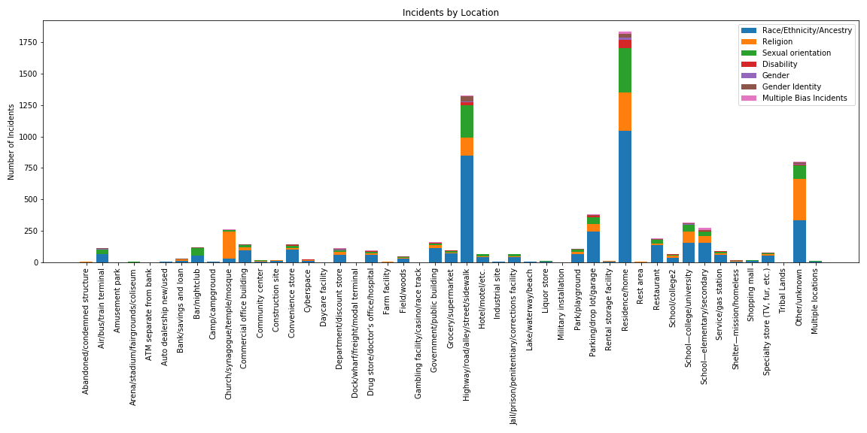

Contd. On next page

